Overview

The Driver Drowsiness Dataset (DDD) contains cropped facial images of drivers classified into two categories: Drowsy and Non-Drowsy. These images have been extracted and cropped from the videos of the Real-Life Drowsiness Dataset.

The frames were captured from the source videos using VLC software. The Viola-Jones algorithm was then applied to detect and extract the face region of interest from each image. This dataset was originally used in the research paper "Detection and Prediction of Driver Drowsiness for the Prevention of Road Accidents Using Deep Neural Networks Techniques".

Dataset Structure
The dataset is organized in a standard image classification folder structure with separate directories for training and testing:
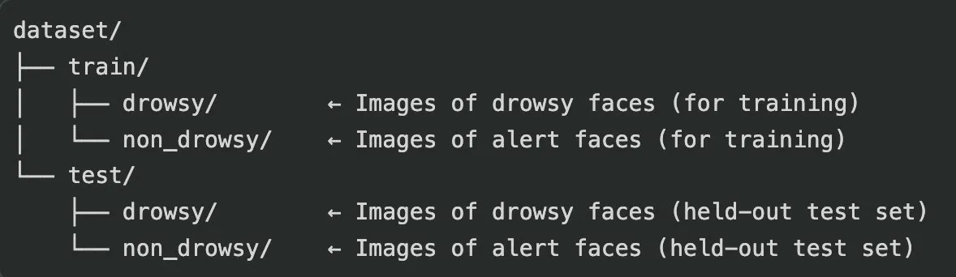

Class Labels
This is a binary classification task with two target classes:
• Drowsy (1): Driver appears to be falling asleep or fatigued.
• Non-Drowsy (0): Driver is alert and awake.

Data Splits

The dataset comes pre-split into training and test sets.

• Training: From the train/ folder — used for model learning.
• Test: From the test/ folder — used only for final evaluation.

Image Details

• Format: JPEG / PNG
• Content: Cropped facial regions of drivers (extracted using the Viola-Jones algorithm).
• Color: RGB (3-channel color images).
• Resizing: Images should be resized to a uniform size (e.g., 128×128) before feeding to the
model.
• Source: Frames extracted from the Real-Life Drowsiness Dataset videos using VLC software.

Key Notes for Learners

• The test set must be kept completely separate and used only for final evaluation — never for
training or hyperparameter tuning.
• Data augmentation (flipping, brightness changes, zoom, etc.) should be applied.

